How to make a Story Map
- Visit http://storymap.knightlab.com/
- Click “Make a new Story Map”
- Make a free account for your group
  - Requires a gmail
  - Have your designated person either login with their own or make a new one.

- Structured like a PowerPoint add a new slide for each step on the map
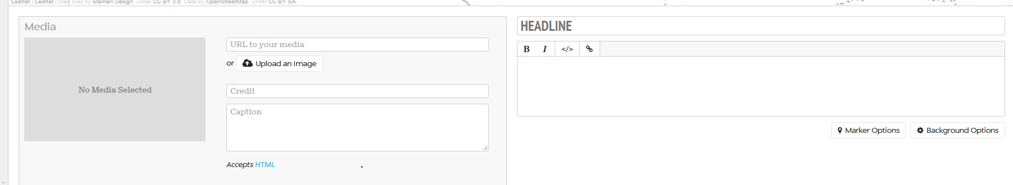
- Double click on the map to drop a pin where you want this slide to appear
- Fill in all the info for each slide
- Your text goes below the Headline box
- Hit save in the upper left often
- When you're done hit share in the upper right
  - make sure all your changes are published
  - Scroll down in the share box and copy the embed code to insert it on your own website

